SPARK: Simple Play Adaptations to Reference for Kids

Hi Ho Cherry-O Built-In Switch Game
Description: | Image:
This counting game includes a game board equipped with two switch plates and two external jacks to accommodate external switches, such as Buddy Buttons, available for loan. Game Board Size: 10″L x 8½” W x 7″H; Spinner Size: 8½” D. Game board requires 4 AA batteries, and the spinner requires 2 AA batteries. Weight: 2¾ lbs. | 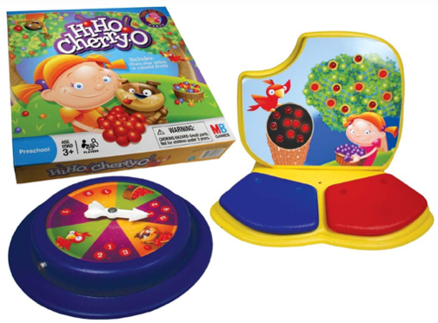  Purchasing Information  User’s Manual

Who Might Benefit?
Those who…
• Benefit from simple cause and effect activities in which the child does something (activates a switch) and the spinner rotates, or the game board lights up.
• Need to further develop reaching, targeting, and hand eye coordination.
• Need engaging visual and auditory materials to support attention to activity.
• Have fine motor challenges and are unable to engage in typical board game activities (rolling dice, picking up or moving game tokens, etc.).
• Have limited mobility or ability to assume varied play positions.
• Are developing an understanding of one-to-one correspondence and/or simple addition and subtraction up to ten.
• Need more opportunities to interact with peers.

Why Use?
Provides an opportunity to…
• Develop experience using simple switches.
• Participate in an engaging activity with multi-sensory supports (sounds, bright colors, lights, switch-activated spinner, etc.).
• Practice identifying colors, counting, hand-eye coordination, and problem solving.
• Practice one-to-one correspondence.
• Develop cooperative play behaviors such as turn taking.
Instructions for Use: | Adaptation Ideas:
Environmental Considerations  - A flat surface (tabletop or floor) is needed with enough space for the adapted game board, spinner, game board for additional players, and any additional switches.  - Use in any environment including community, home, and school. The product does have lights and sounds which may be disruptive in quiet environments.  Positioning  This game can be set up to allow access to users with multiple positional needs.  Position the child (sitting at a table, sitting on the floor, or lying on their tummy on the floor) along with peer players so that they can view the game boards and reach the adapted game board and spinner switches.  Alternate Positioning  - Place spinner on tilted surface such as a 3-ring binder and stabilize with Dycem, shelf-liner, or Velcro for easy viewing.  Basic Play/Use  Each player begins with a “tree” on the game board with 10 cherries on it. Players take turns spinning a spinner and following the action it indicates.  Players activate the game’s spinner by pressing its rim or using a switch.  If the spinner lands on a space with cherries, players take that many cherries from their tree and place them into their bucket.  If the spinner lands on a Dog or Bird, players take 2 cherries from their bucket and place them back on their tree. (If players only have one cherry, they put that one on their tree. If they have no cherries, they do nothing.).  - If the spinner lands on a spilled bucket, players take all the cherries from their bucket, put them back on their tree, and start over.  The child using the adapted game board pushes the red switch plate to pick a cherry off the tree and hears a tone. If the spinner shows they must return fruit to the tree, they push the blue switch. Each time the blue switch is pushed, one cherry goes back on the tree and a different tone will sound.  The first child to empty their tree and/or fill their basket announces, “Hi Ho Cherry-O” and wins the game.  Extended Play/Use  Replace the pictures of cherries on the spinner with numbers to depict how many cherries are picked.  Create a bigger game surface using large pieces of construction paper to depict the trees, bean bags, to represent the cherries, and plastic baskets from the dollar store for the fruit baskets.  - Take photos of the games in the Built-In Switch Adapted Game Kit and print the photos. Create a foam board choice board and encourage the child to select which game they would like to play. When the child selects, honor their choice by providing the selected game. Begin by providing 2 choices adding additional choices as the child tolerates.  Play/Use with Others  - Encourage the players to count together during each child’s turn.  - Give each child a turn using the adapted game board.  - Develop social scripts as necessary to teach turn taking.  - Model and teach turn taking with a “your turn” card or by saying “your turn”  - Teach sportsmanship using words like “good game”. | Optional Additional Materials/Supplies  - Foam board  - Velcro  - Dycem or shelf liner  - Carpet square  - Textured fabric  Build It Up  - Enlarge switch surface with foam board.  Stabilize It  - Velcro bottom of switch and/or gameboard to carpet or use Dycem or shelf liner to keep games and switches from shifting out of reach.  - If the child is having difficulty controlling their reach to the game board switches, encourage the child to rest their forearm on the table while engaged in the activity which requires less control than using the entire arm.  Simplify It  - Reduce the number of cherries needed in the bucket to less than ten to win the game.  - To encourage addition and subtraction skills, provide a number line from 1-10.  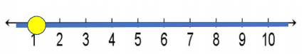  - Turn number line into a manipulative using a bead and a pipe cleaner.  Add Sensory Cues  - Apply various textures to switch surfaces to add tactile interest.  - A picture symbol could be added to the switch to indicate that pushing the switch produces action.  Communication Support  - Use “Wait”, “My turn”, “Your turn”, “First/Then” cards.  - Use a script to provide the child with language to use during the game as well as a reminder of the rules. For example, “I got _____ (1, 2, 3, 4) so I can pick _____ (1, 2, 3, 4) cherry(ies).” “I got the _____ (dog/bird). Put back 2 cherries”.  Alternative Uses  - Make a card to point to with the words Hi Ho Cherry-O or record the phrase on a voice output device for anyone unable to say the words when their bucket has ten cherries in it.  - Encourage the children to make up similar games with groups of ten like objects (Legos, crayons, playdoh containers), moving them from one source (colored paper, carpet square, various containers) to another based on what the spinner shows.  - Different types of switches could be trialed if the included switch is not usable by the child. The OCALI lending library has several kits with multiple types of switches that can be trialed.  DIY Alternatives  - Using typical Hi-Ho Cherry-O game board, recreate spinner choices using playing cards.  - Create a tactile number line for each player using a number line (1-10 printed on cardstock and laminated), a pipe cleaner, and a colored bead corresponding to the colors of the “fruit” in the game. See DIY number line directions.

Additional Considerations:
- CHOKING HAZARD-Small parts. Not for children under 3 years.
- Batteries are required to be installed in both the spinner and the game board for the game to work properly.

Resources:
- How to play Hi Ho Cherry-O YouTube Video
- OCALI Grab and Go Gallery of Resources: Turn Taking https://www.ocali.org/project/resource_gallery_of_interventions/page/Turn-Taking-Supports
- Create a Choice Board - The OCALI Autism Center Grab and Go Resource Gallery of Interventions has a number of choice board templates and examples that could be used to create the choice boards indicated above in the Extended Play/Use section. Additionally, there are several examples of different ways choice boards can be effectively displayed.
- Notes Concerning Hi Ho Cherry-O from Iowa Early Developmental Education.

Ohio Early Learning Standards:
- MA: Number Sense: Develops understanding of the stable order of the counting sequence and learns to recite numbers in order (1.a.).
- MA: Number Sense: Develops understanding of one-to-one correspondence and cardinality (1.b.).
- SC: Science Inquiry and Application: Develops ability to reason about cause and effect. (1.b.).

Words to Encourage Play/Use
Your turn  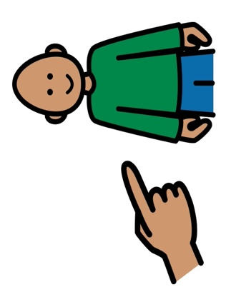 |   My Turn | Done  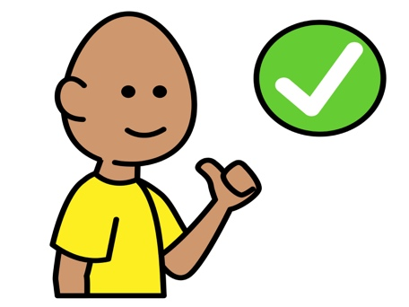
More  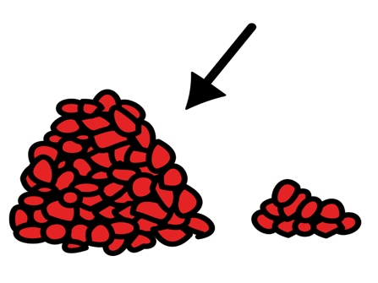 | Help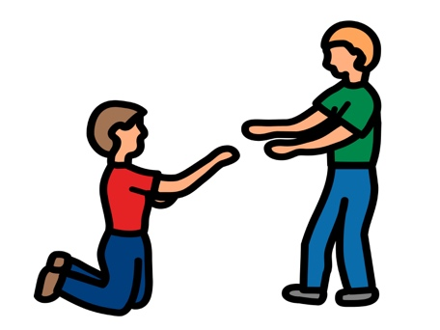 | Many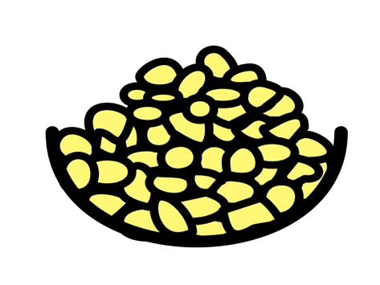
Stop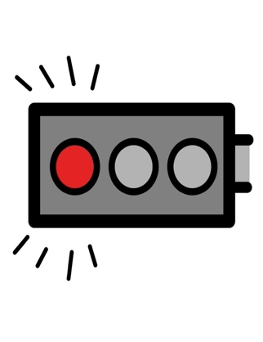 | Go | Push
*”Adaptations” adapted from: Haugen’s Modes for Adapting Toys based on materials from the "Let's Play" Project at the University of Buffalo
PCS is a trademark of Tobii Dynavox, LLC. All rights reserved. Used with permission.

